**Digitalizing Healthcare Architecture**

**An Engineering Project in Community Service**

**Phase – II Report**

***Submitted by***

**Sudhanwa Bokade - 20BAI10302**

***in partial fulfilment of the requirements for the degree of***

***Bachelor of Engineering and Technology***



**VIT Bhopal University**

**Bhopal**

**Madhya Pradesh**

**March, 2023**



**Bonafide Certificate**

Certified that this project report titled **“Digitalizing Healthcare Architecture”** is the bonafide work of “20BCE10302 Sudhanwa Bokade” who carried out the project work under my supervision.

This project report (Phase II) is submitted for the Project Viva-Voce examination held on **9th March 2023**.

**Supervisor**

**Dr. VVPRVB Suresh Dara**

**Comments & Signature (Reviewer 1)**

**Dr Soumitra Nayak**

**Comments & Signature (Reviewer 2)**

**Dr Manisha Jain**

**INDEX**

|  |  |  |
| --- | --- | --- |
| Sl. No. | Topic | Page No. |
| 1. | Introduction | 1 |
| 1.1 | Motivation | 2 |
| 1.2 | Objective | 2 |
| 2. | Existing Work | 4 |
| 3. | Topic of the work | 5 |
| 4. | Result and Discussion | 7 |
| 5. | Individual Contribution | 8 |
| 6. | Conclusion | 9 |
| 7. | References | 10 |

**1. INTRODUCTION**

We have been handling a lot of medical indentures like prescriptions, reports, summary, bills in our life. What if we say no more of handling and keeping them arranged in your house? That will save a lot of paper which indirectly saves trees. Yes, you read it correct presenting you "Remeaitree" which reads out as:

`React Based Web App which will transform medical industry using AI

techniques and saving trees

**`**

The master idea works by creating a de-centralized website just like Digilocker but in the field of medical science with the help of two-factor authentication using aadhar and a phone number. The users can log in to the platform and see all their past reports, prescriptions, and medical history which will be visible in a structured format with an option of searching and querying.

In our current version, we will be creating a hospital or subscription-based feature in Remeaitree. This includes AI-based research on any disorders that will be adjourned using DL/ML techniques. Along with this, we will try our best to add a video conferencing application to have an online consulting session with the doctor from their home at their own convenience. The feature won't be limited here. In our future endeavors, the feature will also include BlockChain Technology for keeping patients' data safe and 1mg integration for directly getting medicine delivered as prescribed by doctors.

As we very well know that these kinds of applications can be used in day-to-day life by a few people and for those few people, it might be of occasional use. On understanding the demand and convenience of everyone, we planned to create a PWA which devours as Progressive Web Application. PWA has a unique feature of acting as both a website that can be opened via a web browser or can be added to the home screen as an application. Some prominent examples include:- YouTube [Desktop], and CodeVIT [VIT Platform].

### 1.1 Motivation

We all have seen our parents, family, and friends rushing for a medical emergency foregoing times. Searching for files or past reports at such a crucial time is similar to the worst nightmare that a person can ever think of. Sometimes, some diseases may be co-related and the doctor might need to know that before performing any forthcoming surgeries, he might need to know what has happened with a patient earlier, and most importantly, he might need to know what all doses of drugs the patient is currently pursuing. In order to handle all the processes in a better manner, we planned to create a simple application that can handle all of these. With the same, we all have even seen sometimes few places management forces doctors to work for money and waste a lot of patient's money. So, for saving this money we added the power of AI for confirming the disease and crosschecking for patients.

### 1.2- Objective

There is an old adage, ‘out of sight out of mind’. We all intermittently are liable to forget things with time and sometimes when it is much needed at that hour. By virtue of this, we came together to think of how we could contribute to the community in a better way. This project will not only make things easier for all the doctors but would also be beneficial to all the patients in the world not waste their efforts in handling all the different reports of different problems at a time. In this way, we could integrate the modern world which is mainly based on AI, with the old medicine world. AI can do wonders and we have seen many wonders in the field of medicine with the power of AI. Also helping others is not only good for them and a good thing to do, but it also makes us happier and healthier too. Giving also connects us to others, creating stronger communities and helping to build a happier society for everyone. And it's not all about money - we can also give our time, ideas, and energy.

**2. EXISTING WORK OR LITERATURE REVIEW**

We are imperatively building this project to make the system of fetching and storing reports easier. Before starting to work on it, we had to research if such software is available in the tech industry at present or not. After visiting many hospitals, we analysed that not all hospitals had a centralized system of working. Some private hospitals do have a synchronized system but that isn't available for all hospitals. We primarily will make this a decentralized system. Along with this, so far not many hospitals are implying AI support in their workplace or daily life. We additionally want the maximum number of people to get aware of this technology so implying AI is also one of our essential mottos. We are using AI support to detect the disease, and though we assure you it would detect the disease and suggest cures, still the patient will have to consult a doctor for further verification of the detected disease and its cure. We are combining different AI models into one and we are sure that this hadn't been done before but our project will change the entire existing system by easing the work. We are helping the community as a whole, i.e patients and doctors with this software.

Along with this, we are trying to implement blockchain technology which no one has used before in this field. We are implementing this just to prevent the hacking of data with the help of modern technology. We are amalgamating all the hospitals to be united for the sake of the health of a patient and this is evidently not done by anyone if the past. All that matters for every doctor are to just try his best to save the life of their patient. Instead of wasting time in getting the past reports of the patient, they can access all of it with a click, then why not? We are very well aware that it's not an easy task to gather so much data and store it but we will try our best to incorporate everything in the easiest way possible.

**3. Topic Of The Work**

1. **System Design / Architecture**

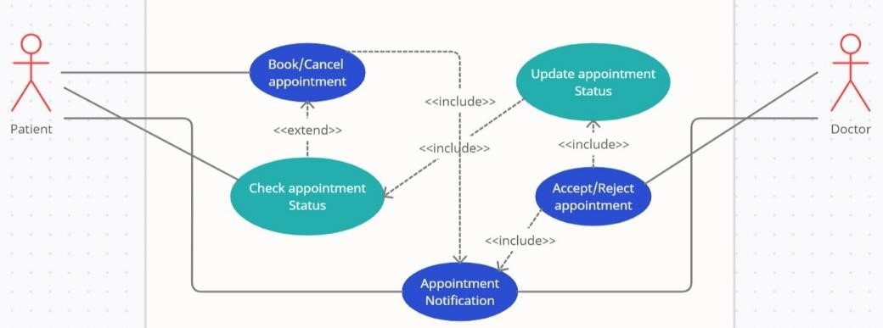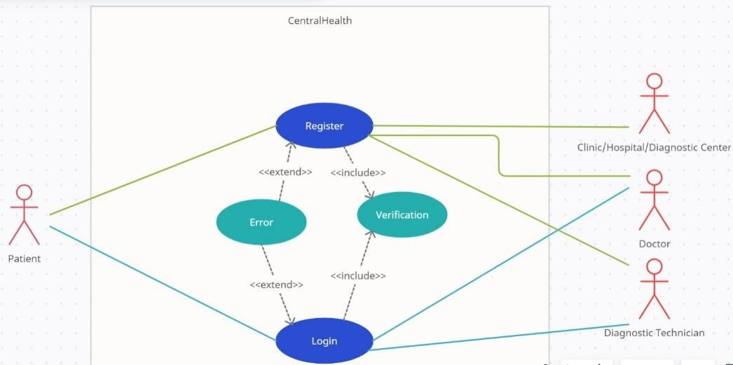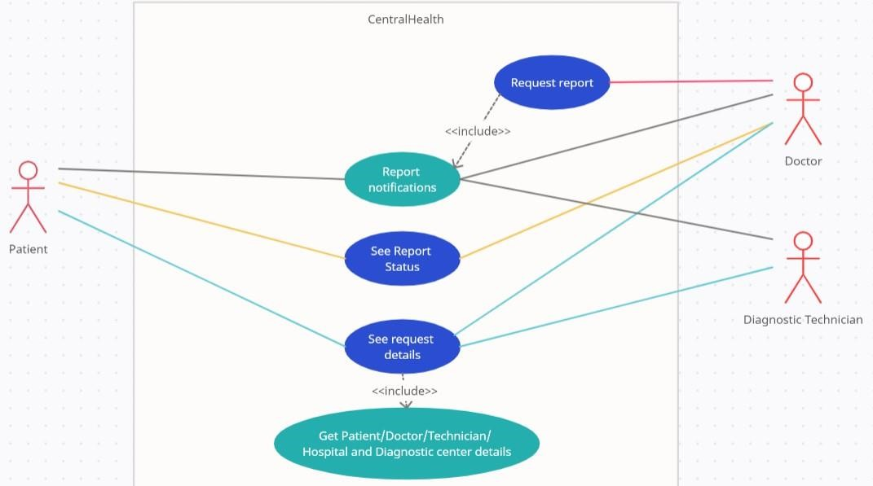

1. **Working Principle**

We are a good team together and honestly to date we are just done with several discussions of our idea and how can we make this project more effective. Along with this, we did thorough research in many civil and private hospitals on how is the working exactly done. We are clear with the complete workflow of how we will work and what else we can add in the process of making our project the best. We are also working on the making of our website and we have divided the work and will be done with it soon.

## 4. Results and Discussion

AI-based research on any disorders that will be adjourned using DL/ML techniques. The users can log in to the platform and see all their past reports, prescriptions, and medical history which will be visible in a structured format with an option of searching and querying

A long time ago our society accepted the notion of treating people with disabilities not as unviable and disabled but as differently abled, recognizing their skills beyond their disabilities. The next step must be taken by our scientific community, that is, to normalize lives of the people with disabilities and make it so as if they are no different to us. The primary step in this direction would be to normalize communication between people.

**5. Individual Contribution**

My teammates Janhvi Rajyaguru, Hemang Jiwnani and I developed API models for prediction of over 30 diseases - Thyroid Detection, Malaria Prediction, Covid-19, Breast Cancer, Lung Cancer, Skin Cancer, Cervical Cancer, Prostate Cancer, Blood Cancer, Leukaemia Cell (Childhood Cancer), Histopathologic Cancer Detector, Ovarian Cancer, Parkinson Disease, Detection Cataract, Diabetes Classification, ABG (Acid-Base Disorder), COPD (Spirometry Test), Heart Disease, Tuberculosis, Hepatitis C Dataset, Cirrhosis Prediction, Brain Tumor ,Flu Prediction, HIV Prediction, Pneumonia Detection, Chonic Kidney Detection, Early Alzheimer's, Autism, Liver Disease Detection, and Brain Cancer. Siddhesh Khope developed API for the given models.

Aman Singh along with Yash Ukalkar and Joel Jaji Varghese developed frontend a backend of the website and some other component like video conferencing and UI design of website was made by Harsh Selukar .

Yash developed the sign in page and Joel developed the video conferencing feature to website.

**My contribution** – I developed/trained models for detecting harmful diseases like Dengue, Malaria, Covid -19,Breast Cancer, Lung Cancer, Skin Cancer, Cervical Cancer , prostate cancer , Blood Cancer , Leukaemia , etc. These models were trained with the help of Convolution Neural Networks (CNN) for which there was an image data whereas Machine Learning was used where the dataset was in the form of data frames. These models were built with a view of enabling the users to diagnose the diseases at home and to take them out of the hassle of visiting the hospitals every now and then.

**6. Conclusion:**

We are a good team together and honestly to date we are just done with several discussions of our idea and how can we make this project more effective. Along with this, we did thorough research in many civil and private hospitals on how is the working exactly done. We are clear with the complete workflow of how we will work and what else we can add in the process of making our project the best. Till now we have trained the model and developed the api for the model . We have also completed the frontend of the website .The things left are integration of AI models with video feature page. While we think your suggestion could potentially benefit the project, we are confident that going with the ongoing workflow will yield much more positive results keeping all the alternative approaches into consideration

1. **References**

Following are few of the sources we have analysed and gone through and which helped us to formulate this idea:

* 1. <http://proceeding.conferenceworld.in/ESHM-2019/5RepSP9ZonR1012.pdf>
  2. [https://create.arduino.cc/projecthub/skyseeker/deaf-blind-communicationwith-1sheeld-arduino-bb3362](https://create.arduino.cc/projecthub/skyseeker/deaf-blind-communication-with-1sheeld-arduino-bb3362)
  3. [https://www.instructables.com/COMMUNICATION-BETWEEN-THEBLIND-AND-DEAF-USING-ARD/](https://www.instructables.com/COMMUNICATION-BETWEEN-THE-BLIND-AND-DEAF-USING-ARD/)